**PROBLEM STATEMENT:**

Define two structures, polar and rectangular, with required members to define a polar and rectangular quantity respectively. Provide functions to

1. Create and display these structure variables
2. Add two structure variables of
   1. Similar type
   2. Different type

Write a main program to test the above functions.

**PROGRAM CODE:**

#include<iostream.h>

#include<conio.h>

#include<math.h>

#define pi 3.141592654

struct rect

{

float x,y;

}r[10];

struct pol

{

float r,th;

}p[10];

void creater(int i)

{

cout<<"Enter the x"<<i+1<<": ";

cin>>r[i].x;

cout<<"Enter the y"<<i+1<<": ";

cin>>r[i].y;

}

void createp(int i)

{

cout<<"Enter the magnitude r"<<i+1<<": ";

cin>>p[i].r;

cout<<"Enter the angle theta(radian)"<<i+1<<": ";

cin>>p[i].th;

}

void dispr(rect a)

{

cout<<"\n"<<a.x<<"+j"<<a.y;

}

void dispp(pol a)

{

cout<<"\n"<<a.r<<"(cos"<<a.th<<"+ jsin"<<a.th<<")";

}

void addrr(rect a,rect b)

{

float m,n;

m=a.x+b.x;

n=a.y+b.y;

cout<<"\nResult: "<<m<<"+ j"<<n;

cout<<"\nPress Enter key!\n";

getch();

}

void addpp(pol a,pol b)

{

float m,n,p,q;

m=((a.r)*cos(a.th)+(b.r)*cos(b.th));

n=((a.r)*sin(a.th)+(b.r)*sin(b.th));

p=sqrt((m*m)+(n*n));

if(m>0&&n>0)

q=atan(n/m);

else if(m<0&&n>0)

q=pi+atan(n/m);

else if(m<0&&n<0)

q=atan(n/m)-pi;

else

q=atan(n/m);

cout<<"\nResult: "<<p<<"(cos"<<q<<"+ jsin"<<q<<")";

cout<<"\nPress Enter key!\n";

getch();

}

void addrp(rect a,pol b)

{

float m,n,p,q;

m=(b.r)*cos(b.th);

n=(b.r)*sin(b.th);

p=a.x+m;

q=a.y+n;

cout<<"\nResult: "<<p<<"+ j"<<q;

cout<<"\nPress Enter key!\n";

getch();

}

main()

{

int ch,nr,np,i,j,k;

cout<<"Enter the number of rectangular quantities: ";

cin>>nr;

cout<<"Enter the number of polar quantities: ";

cin>>np;

for(i=0;i<nr;i++)

creater(i);

for(i=0;i<np;i++)

createp(i);

for(i=0;i<nr;i++)

dispr(r[i]);

for(i=0;i<np;i++)

dispp(p[i]);

start:

cout<<"\n\nChoose one of these: \n1. Rect + Rect\n2. Pol + Pol\n3. Rect + Pol\n";

cin>>ch;

switch(ch)

{

case 1:

cout<<"Enter which two Rectangular quantities you wish to add: ";

cin>>j>>k;

addrr(r[j-1],r[k-1]);

goto start;

case 2:

cout<<"Enter which two Polar quantities you wish to add: ";

cin>>j>>k;

addpp(p[j-1],p[k-1]);

goto start;

case 3:

cout<<"Enter which Rectangular quantity and Polar quantity you wish to add: ";

cin>>j>>k;

addrp(r[j-1],p[k-1]);

goto start;

default:

cout<<"Invalid choice!";

goto start;

}

getch();

}

**OUTPUT:**

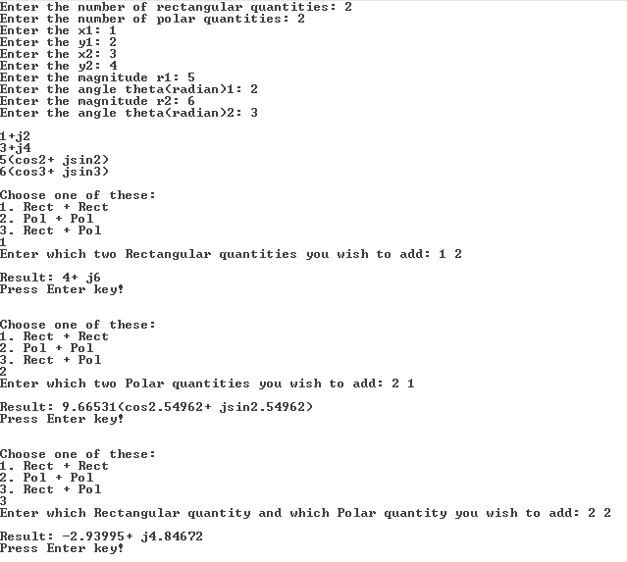

**RESULT:**

The structures are defined and various operations are performed on them using functions. A main program is written as well, to test these functions.